Dynamic ETL & AI Powered RAG System

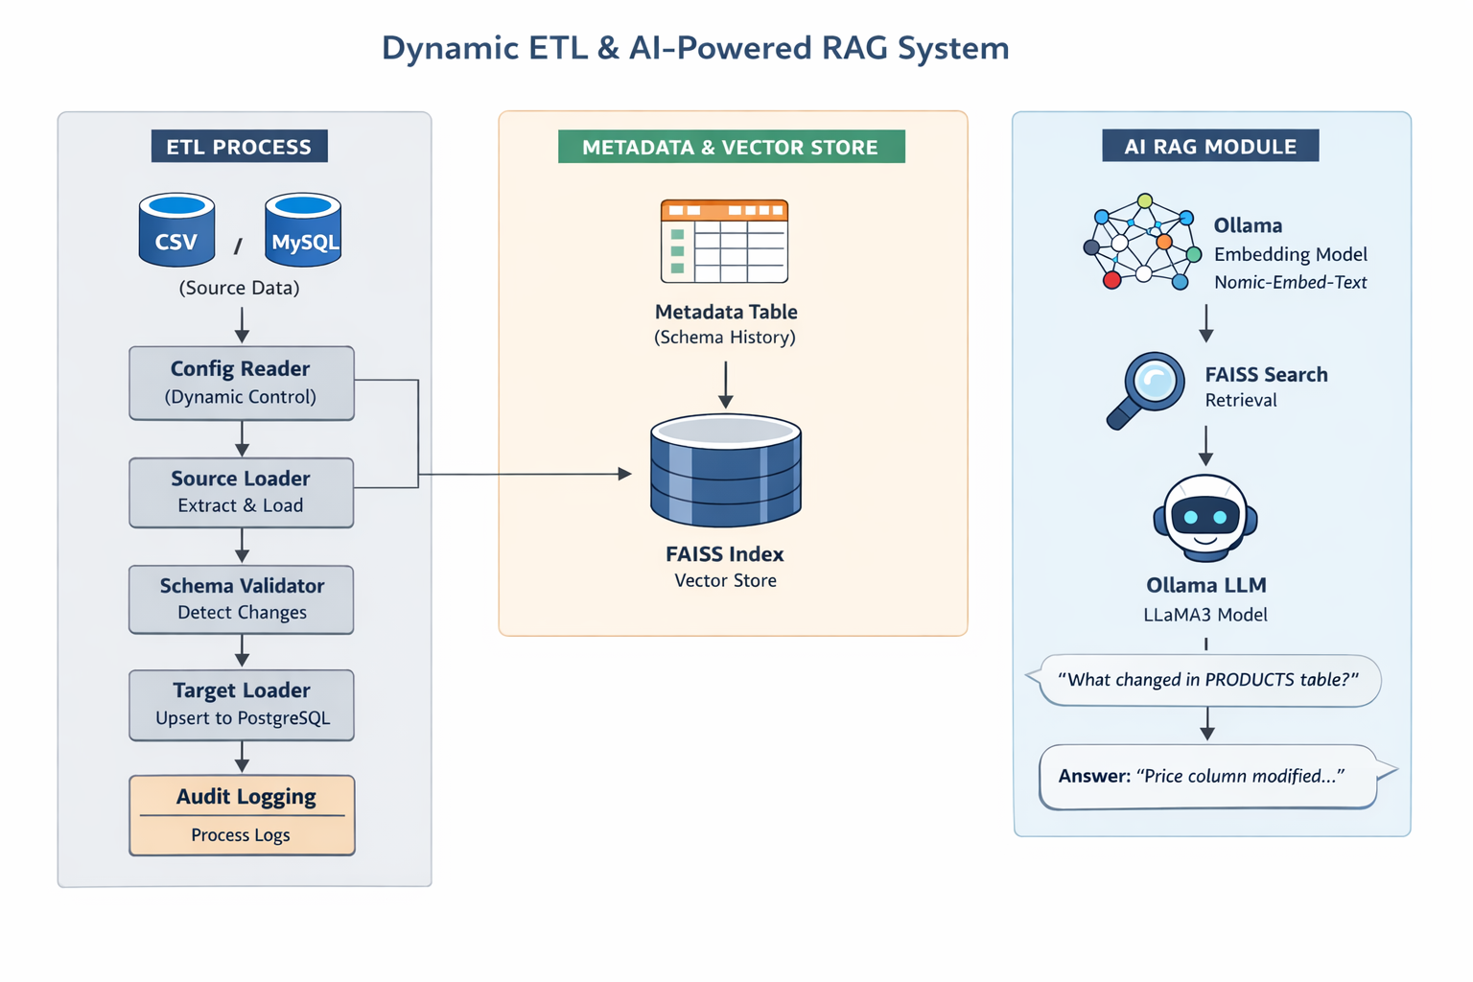

PROJECT SUMMARY

Dynamic ETL Framework + Schema Drift Detection + AI-powered RAG Assistant

A system that automatically loads data, tracks schema changes, and allows users to ask questions about data using AI.

ARCHITECTURE OVERVIEw

ETL Layer
- Reads data from:
  - CSV
  - MySQL
- Loads into:
  - PostgreSQL

Metadata + Schema Tracking Layer
- Captures:
  - Column names
  - Data types
  - Order
- Detects:
  - ADD / REMOVE / MODIFY

AI (RAG) Layer
- Converts metadata → embeddings
- Stores in FAISS
- Uses LLM (Ollama) to answer questions

COMPLETE FLOW (STEP BY STEP)

STEP 1: Read Config (Dynamic Control)
File: config_reader.py
Reads from:
dyn_etl.process_control
Defines:
- Source type (CSV / MySQL)
- File path / table
- Target table
- Primary key
This makes pipeline fully dynamic

STEP 2: Load Source Data
File: source_loader.py
- CSV → pandas.read_csv()
- MySQL → SELECT *
Output:
DataFrame (df)

STEP 3: Schema Extraction
File: schema_engine.py
Extracts:
- column_name
- data_type
- ordinal_position

STEP 4: Metadata Validation (CORE LOGIC)
File: schema_validation.py
Logic:

First Run:
No metadata → store schema

Next Runs:
Compare with existing metadata
Detect:
- ADD column
- REMOVE column
- MODIFY datatype

STEP 5: Store Metadata
Table: dyn_etl.metadata
Stores:
- Column details
- Action type
- Timestamp
This is your data lineage + schema history

STEP 6: Create Target Table
File: target_loader.py
Creates dynamically:
CREATE TABLE IF NOT EXISTS
Based on DataFrame columns

STEP 7: Load Data (UPSERT)
Uses:
ON CONFLICT DO UPDATE
Insert + Update in one query

STEP 8: Audit Logging
File: audit.py
Stores:
- Start time
- End time
- Insert count
- Update count
- Status
Table:
dyn_etl.process_control_details

AI (RAG) FLOW

STEP 9: Convert Metadata → Text
embed_metadata.py
Example:
Table: CUSTOMERS
Column: age
Type: int
Action: ADD

STEP 10: Create Embeddings
embedder.py
Uses:
- Ollama
- Model: nomic-embed-text
Converts text → vector (numbers)

STEP 11: Store in FAISS
vector_store.py
FAISS:
- Fast similarity search
- Finds closest matching data

STEP 12: Retrieve Context
retriever.py
Converts query → embedding
Finds similar metadata

STEP 13: Generate Answer
rag_pipeline.py
Uses:
- Ollama (llama3)
- Combines:
  - User question
  - Retrieved metadata
Generates final answer

STEP 14: Chat Interface
run_rag.py
AI-powered RAG chatbot (inside a UI)
home.py
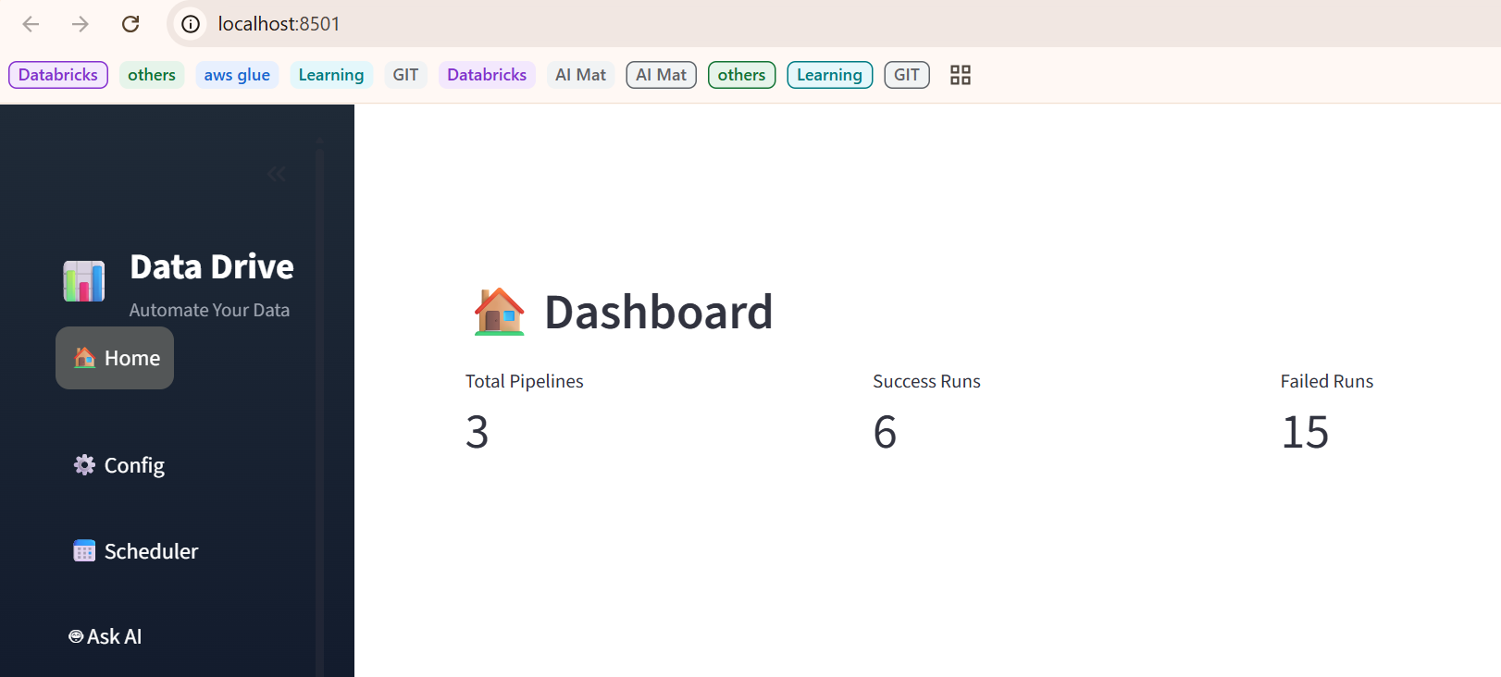

Config.py
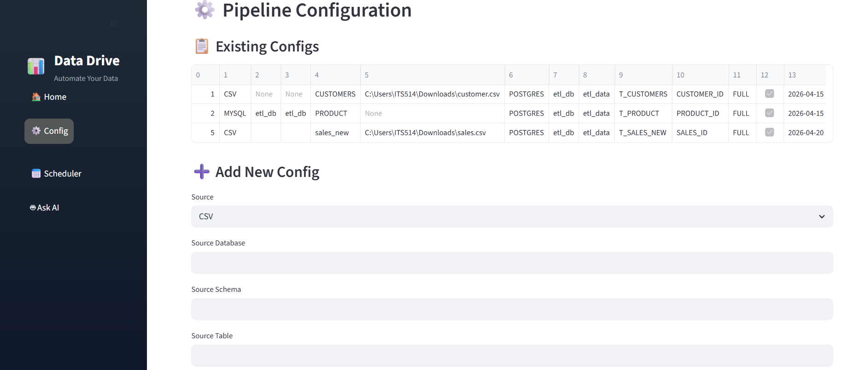

Scheduler.py
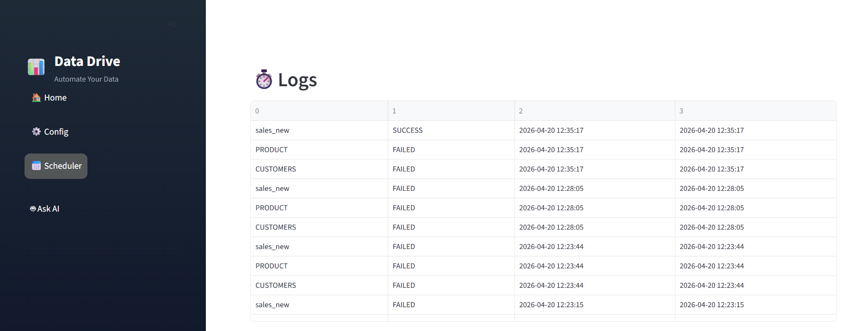

Ask ai.py
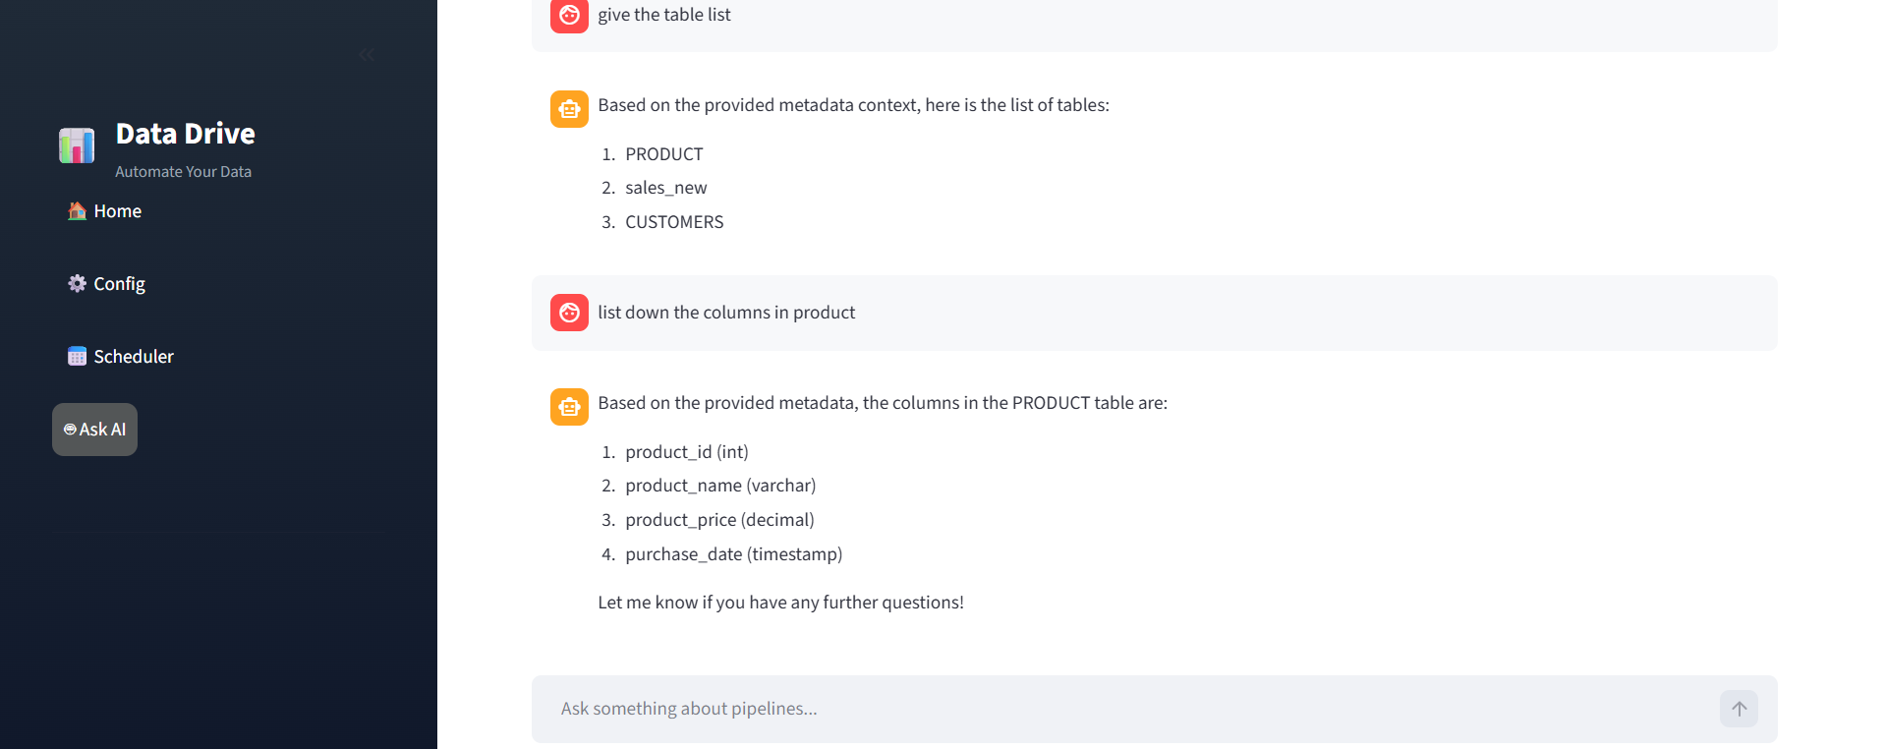

TECHNOLOGIES USED

Data Engineering
- Python
- Pandas
- PostgreSQL
- MySQL

ETL Concepts
- Dynamic pipeline
- Incremental loading
- Upsert logic
- Schema drift detection

AI / ML
- Ollama (Local LLM)
- Embeddings
- FAISS (Vector DB)
- RAG (Retrieval-Augmented Generation)

CORE MECHANISMS

1. Schema Drift Detection
Compare:
Source Schema vs Metadata Table

2. Upsert Logic
ON CONFLICT (PK) DO UPDATE

3. Embeddings
Convert text → vectors
Used for similarity search

4. FAISS Search
Finds nearest vectors (semantic search)

5. RAG
Retrieval + LLM
Instead of guessing, model answers based on your data

FUTURE ENHANCEMENTS
Level 1
- Auto ALTER TABLE on schema change
- Email/Slack alerts

Level 2
- Real-time pipeline (Kafka + Debezium)
- API-based pipeline trigger

Level 3 (Advanced)
- Multi-table lineage graph
- Data quality checks
- AI auto SQL generator

